Update a file through a Python algorithm

Project description
At my organization we control access to content using a list of allowed IP addresses. The "allow_list.txt" file contains these IP addresses. We also have a list of IP addresses that should no longer have access to this content. I created an algorithm to update the "allow_list.txt" file and remove IP addresses that should no longer have access.

Open the file that contains the allow list
I started by opening the "allow_list.txt" file. I assigned the file name to a variable called import_file:

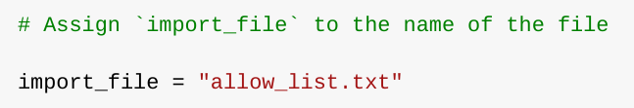

Then, I used a with statement to open the file:

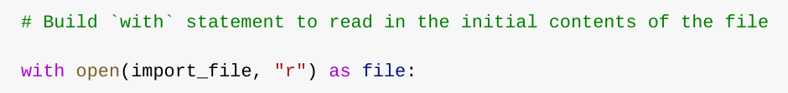

The with statement helps manage resources by closing the file after I'm done with it. I opened the file in read mode, which allows me to access the IP addresses stored in the file.

Read the file contents

In order to read the file contents, I used the .read() method to convert it into the string.

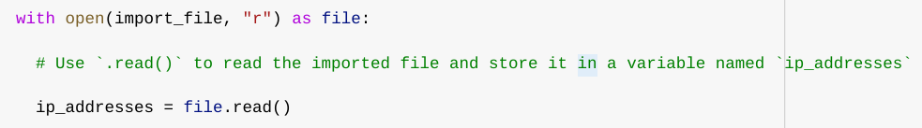

The.read() method converts the file into a string, which I can then read. I assigned the string output to a variable called ip_addresses.
In summary this code reads the contents of the "allow_list.txt" file into a string format. This allows me to use the string to organize and extract data in my Python program.

Convert the string into a list
To remove IP addresses from the allow list I needed to convert the string into a list. I used the.split() method to convert the ip_addresses string into a list:

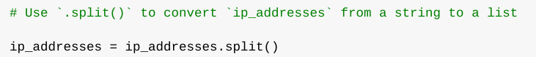

The.split() function converts the contents of a string to a list. I used it to split the ip_addresses string into a list of IP addresses.

Iterate through the remove list
A key part of my algorithm involves iterating through the IP addresses in the remove_list. I used a for loop:

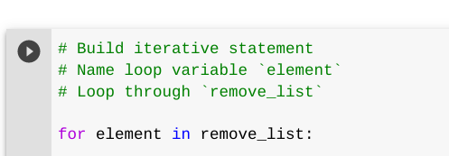

The for loop repeats code for a sequence. In this case it iterates through the IP addresses in the remove_list. Assigns each value to a loop variable

Remove IP addresses that are on the remove list
My algorithm requires removing any IP address from the allow list, ip_addresses, that is also in the remove_list. I used a statement to check if the loop variable was in the ip_addresses list. If it was I removed it:

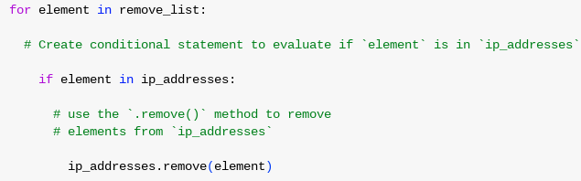

I used the.remove() method to remove the IP address from the ip_addresses list.

Update the file with the revised list of IP addresses
As a final step in my algorithm, I needed to update the allow list file with the revised list of IP addresses. To do so, I first needed to convert the list back into a string. I used the .join() method for this:

As a step I needed to update the allow list file with the revised list of IP addresses. I used the.join() method to convert the list into a string:

The.join() method combines all items in an iterable into a string. I used it to create a string from the ip_addresses list

Then, I used another with statement and the .write() method to update the file:

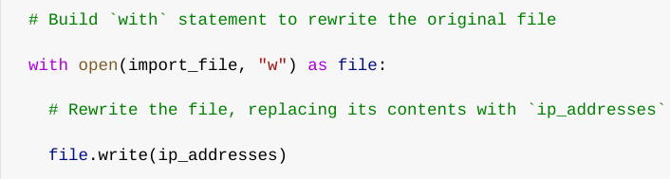

This time I opened the file in write mode, which allows me to write over its contents. I used the.write() method to write the updated allow list as a string to the file "allow_list.txt".

In this case I wanted to write the updated allow list as a string to the file "allow_list.txt". This way restricted content will no longer be accessible to IP addresses that were removed from the allow list.

Summary
I created an algorithm that removes IP addresses from the "allow_list.txt" file of approved IP addresses. The algorithm involves opening the file converting it to a string and then converting the string to a list. I then iterated through the IP addresses in the remove_list. Removed any that were, in the ip_addresses list. Finally I used the.join() method to convert the ip_addresses list into a string and wrote it to the "allow_list.txt" file.

